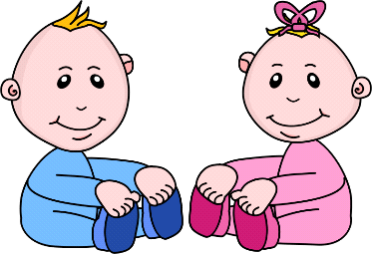Infant Room Lesson Plan
Date: Monday June 8th – Friday June 12th 2020
Teachers: Ms. Cici, Ms. Jessie, Ms. Carmen, Ms. Christine, and Ms. Emily
Bible verse: "Jesus Prayed" (Luke 5:16)
My family works in many ways
Books  Diaper bag books: Place four books in a diaper bag. Hang the bag on the side of the rocking chair. As you are rocking a baby, pull out a book and share it with the child. | Motor Development  Lids: Place a plastic pan with a lid on the floor next to a child that can sit up on their own. Encourage the baby to turn the pan over and place the lid on top of the pan. Talk to the baby as they try.
Art  Coloring Dishes: Print out different dishes that can be cut out and colored, have the babies work together to glue the dishes on a piece of paper. | Music  Moving with a baby: Play an upbeat children's CD. Hold a baby and move and rotate through the room to the beat. Switch to a slower CD and turn slow circles holding the baby. Take turns with each child.
Nature:  Colorful water play: Fill a plastic dishpan half full of water. Place a tub on a towel on the floor. Put a couple drops of baby soap and let the children splash and play | Toys:  Dishes: Place several plastic child-sized dishes on the floor. Place 2-3 infants that can sit on their own around the dishes. Encourage the babies to make dinner and wash dishes. Use descriptive words.

