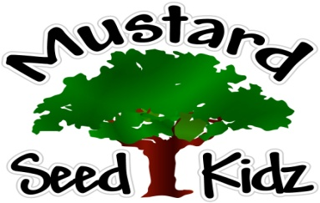

June 1st-5th
Breakfast | Monday | Tuesday |  | Wednesday | Thursday | Friday
 | Multi-Grain Cheerios Cereal  Peaches  Milk | Whole Grain Raisin Bran Apple Slices  Milk |  | Multi-Grain English Muffin w/Jelly Fruit Cocktail Milk | Whole Wheat Life Cereal  Applesauce  Milk | Multi-Grain Wheat Chex Pears  Milk
Lunch | Turkey Taco on Multi-Grain Wrap  Sour Cream  Corn  Applesauce  Milk |  | Sweet & Sour Chicken  White Rice  Sliced Pineapple  Milk | Spaghetti w/ Meat sauce  Green Beans  Tropical Fruit  Milk | Pulled Pork BBQ on a bun  Baked Beans  Sliced Peaches  Milk | Beef Cheeseburger on a bun  Tator Tots w/ Ketchup Oranges  Milk
Snack | Tortilla Chips  Cheese Sauce | Cheez-Itz String Cheese |  | Fresh Apples  Wow Butter | Ritz Crackers  Cheese Slices | Animal Cookies  Applesauce

