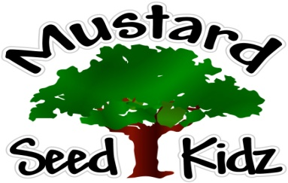

May 11th-15th
Breakfast | Monday | Tuesday | Wednesday | Thursday | Friday
 | Multi-Grain Life Cereal Oranges  Milk | Multi-Grain Pancakes  Pineapple  Milk | Multi-Grain  Mini Wheats Cereal  Peaches  Milk | Multi-Grain English Muffin  Strawberry Preserves  Milk | Whole Grain Cheerios Oranges  Milk
Lunch | Cheese Hot Dogs on a Roll French Fries  Pears  Milk | Chicken Fingers  Green Beans Sliced Apples  Milk | BBQ Kielbasa  Mashed Potatoes  Fruit Cocktail  Milk | Teriyaki Chicken & Rice  Mixed Vegetables  Peaches  Milk | Cheddar & Broccoli Casserole w/ Chicken  Pineapple  Milk
Snack | Chex Mix  Raisins | Cheese Itz  Apple juice | Graham Crackers  Yogurt | Pretzels  Cheese Sauce | Crackers  Cheese Slices

