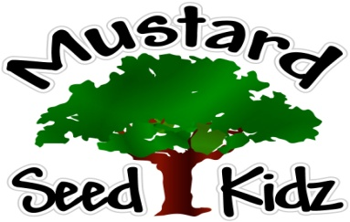
May 18 - 22
Breakfast | Monday | Tuesday | Wednesday | Thursday | Friday
 | Strawberry Mini Wheat Cereal  Pineapple  Milk | Multi-Grain Waffles  Peaches  Milk | Multi-Grain  Life Cereal  Fruit Cocktail  Milk | Multi-Grain Pancake & Sausage  Corn Dog  Milk | Whole Grain Cheerios Mandarin Oranges  Milk
Lunch | Beef Ravioli  Mixed Vegetables  Applesauce  Milk | Corn Dog  Mashed Potatoes  Mandarin Oranges  Milk | Chicken Alfredo  Broccoli  Pears  Milk | Pepperoni Pizza  Mixed Salad w/ Ranch  Pineapple  Milk | Chicken Nuggets  Tator Tots  Tropical Fruit  Milk
Snack | Chex Mix  Raisins | Chips  Salsa | Wheat Thin Crackers  Pepperoni Slices | Animal Crackers  Apple Juice | Pretzels  Cheese Sticks

