MSK Camp
Due to Covid 19 trips can change at any time
 | ~ JUNE 2020 ~
Sun | Mon | Tue | Wed | Thu | Fri | Sat
 | 1 Summer Camp Rules & Art  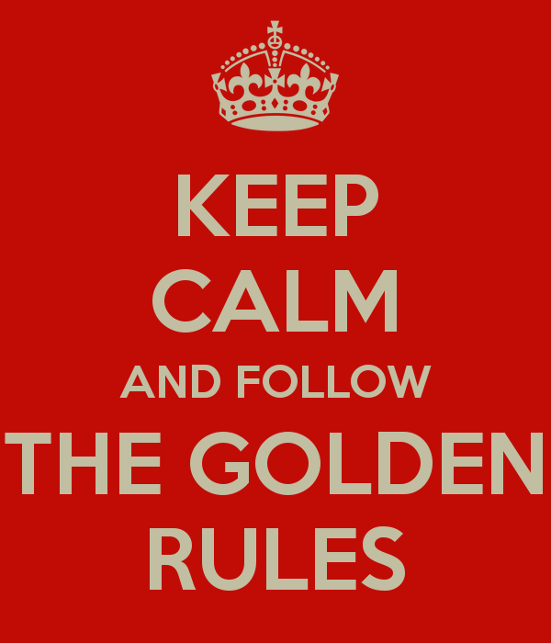  Stay @ MSK | 2 Ryckman Park & Fishing  Leave @ 10:00 | 3 MSK Movie  & Snack  Stay @MSK | 4 Field of Dreams & Picnic  Leave @ 10:00 | 5 Science  Day  Stay @ MSK
 | 8 Pizza Making  Stay @ MSK | 9 Light house cove mini golf  Leave @ 9:00 | 10 MSK Movie & Popcorn  Stay @ MSK | 11 Galaxy Skate way  Leave @10:15 | 12 Fred Lee Park  Relay games  &  Leave @ 10:30
 | 15 Shore lanes Bowling  Leave @ 9:45 | 16 Makotos  Leave @ 9:15 | 17 MSK Movie & Snack  Stay @ MSK | 18 Erna Nixon Park  Leave @ 10:00 | 19 Police Hall A Fame  Leave @ 9:00
 | 22 Turkey Creek & Twisty Cone  Leave @ 10:00 | 23 Mel Fisher Treasure Museum  Leave @ 9:00 | 24 MSK Movie & Popcorn  Stay @ MSK | 25 Laporte Farms  Leave @ 9:00 | 26 Ballard Park & Fishing  Leave @ 10:00
 | 29 Planet 3  Leave @ 9:30  Online Wavier | 30 Wild Florida Airboat Rides  Leave @ 8:30

