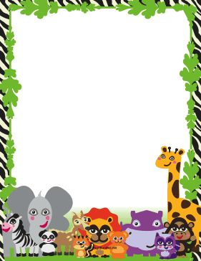
Terrific Three’s & Four’s
Week of: May 25th-May 29th Lesson: Animals live in homes, too
Bible Verse: “God made the animals” (Genesis 1:25)
Letter: Ff Number: 26 Color: Brown Shape: Hexagon
Purpose: The purpose of this unit is to provide opportunities for children to recognize and name zoo animals, to learn that people work to keep zoo animals safe and healthy, and to learn that animals live in homes and have special needs.
March 30^{th-April} 3rd | Monday | Tuesday | Wednesday | Thursday | Friday
Art | Making a zoo animal puppet | Making zoo pictures | Make a blind drawing | Making footprints | Creating a collage
Nature | Using a feely sock | Using puppets | Printing animal tracks | Looking for animal tracks | Sorting animal pictures
Books & Listening | Enjoying a zoo animal book | Looking at Bible pictures | Working with a flannelgraph | Reading a book about the zoo | Making a story up about animals
Blocks | Building a zoo | Taking care of animals | Pretending to be zookeepers | Going on a safari | Feeding animals
Music | Moving like animals | Making animal sounds | Walking on a balance beam | Dancing like animals | Listening to animal sounds
Puzzles & Manipulative | Ordering monkeys | Matching bears | Matching zoo animals | Using wooden puzzles | Stringing beads
Home Living | Working in a zoo kitchen | Visiting a souvenir stand | Decorating cookies | Working at a zoo | Giving zoo animals a bath
Writing | Coloring the letter of the week | Coloring the number of the week | Tracing the letter of the week | Tracing the number of the week | Tracing/color the shape of the week
Kindness Curriculum:  Gifts | Talking about friendships | Sharing with our friends | Working together | Learning to care about our friends | Making gifts for our friends

