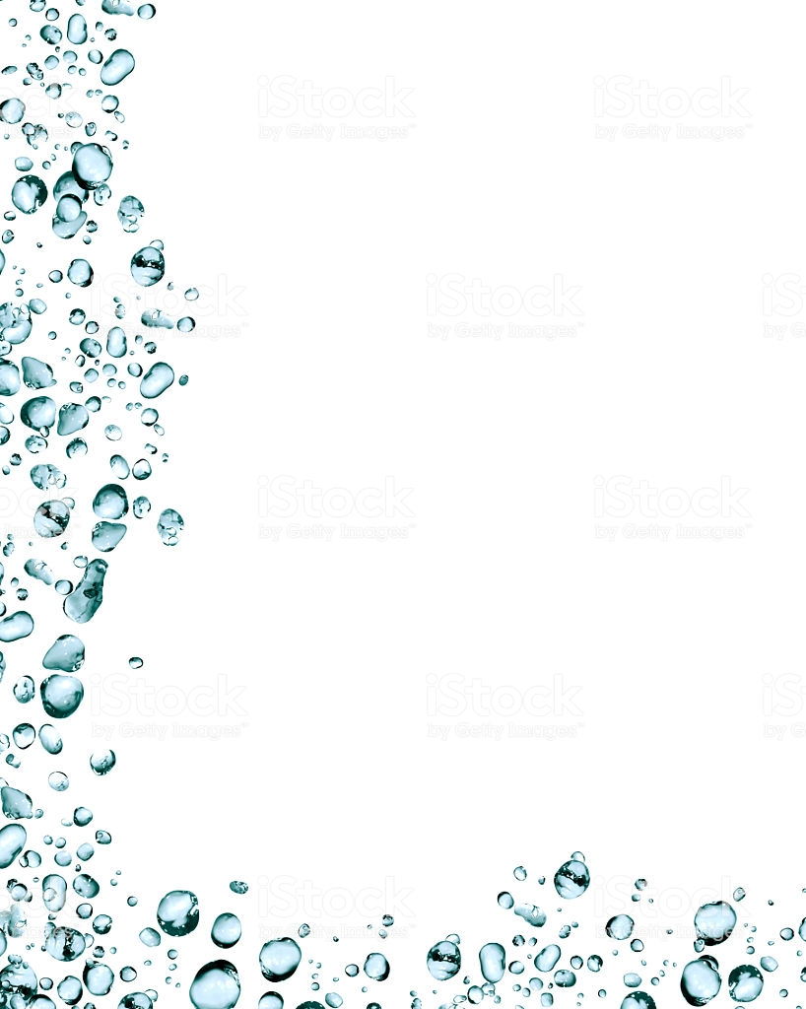
Terrific Three’s & Four’s
Week of: May 4th-May 8th Lesson: Water is fun
Bible Verse: “God made the water” (Psalms 104:10)
Letter: Cc Number: 23 Color: Grey Shape: Octagon
Purpose: The purpose of this lesson is to help children grow in their appreciation of God’s gift of water and to learn that water has many uses and purposes.
May 4th–8th | Monday | Tuesday | Wednesday | Thursday | Friday
Art | Painting on wet paper | Mixing colors | Printing with sponges | Drawing with wet chalk | Painting with spray bottles
Nature | Making waves | Experimenting with magnets and water | Sink and float | Looking through a water magnifier | Exploring ice
Books & Listening | Making a sailboat book | Reading a book about water safety | Listening to rain sounds | Choosing a favorite water activity | Reading books in a swimming pool
Blocks | Building bridges | Washing the car | Going fishing | Going to the beach | Learning about a plumber
Music | Moving like windshield wipers | Looking at water scenes | Taking a bath | Moving with streamers | Staying dry on a rainy day
Writing | Coloring the letter of the week | Coloring the number of the week | Tracing the letter of the week | Tracing the number of the week | Tracing/color the shape of the week
Home Living | Dipping and pouring water | Washing dishes | Making lemonade | Giving the babies a bath | Making take along snacks
Puzzles & Manipulatives | Working wooden puzzles | Using a matching board | Working a magnetic puzzle | Playing a matching game | Lacing
Kindness Curriculum:  Relaxation | What does relaxing mean? | Practice breathing | Doing stretches | Listen to calming music | What is your favorite way to relax?

