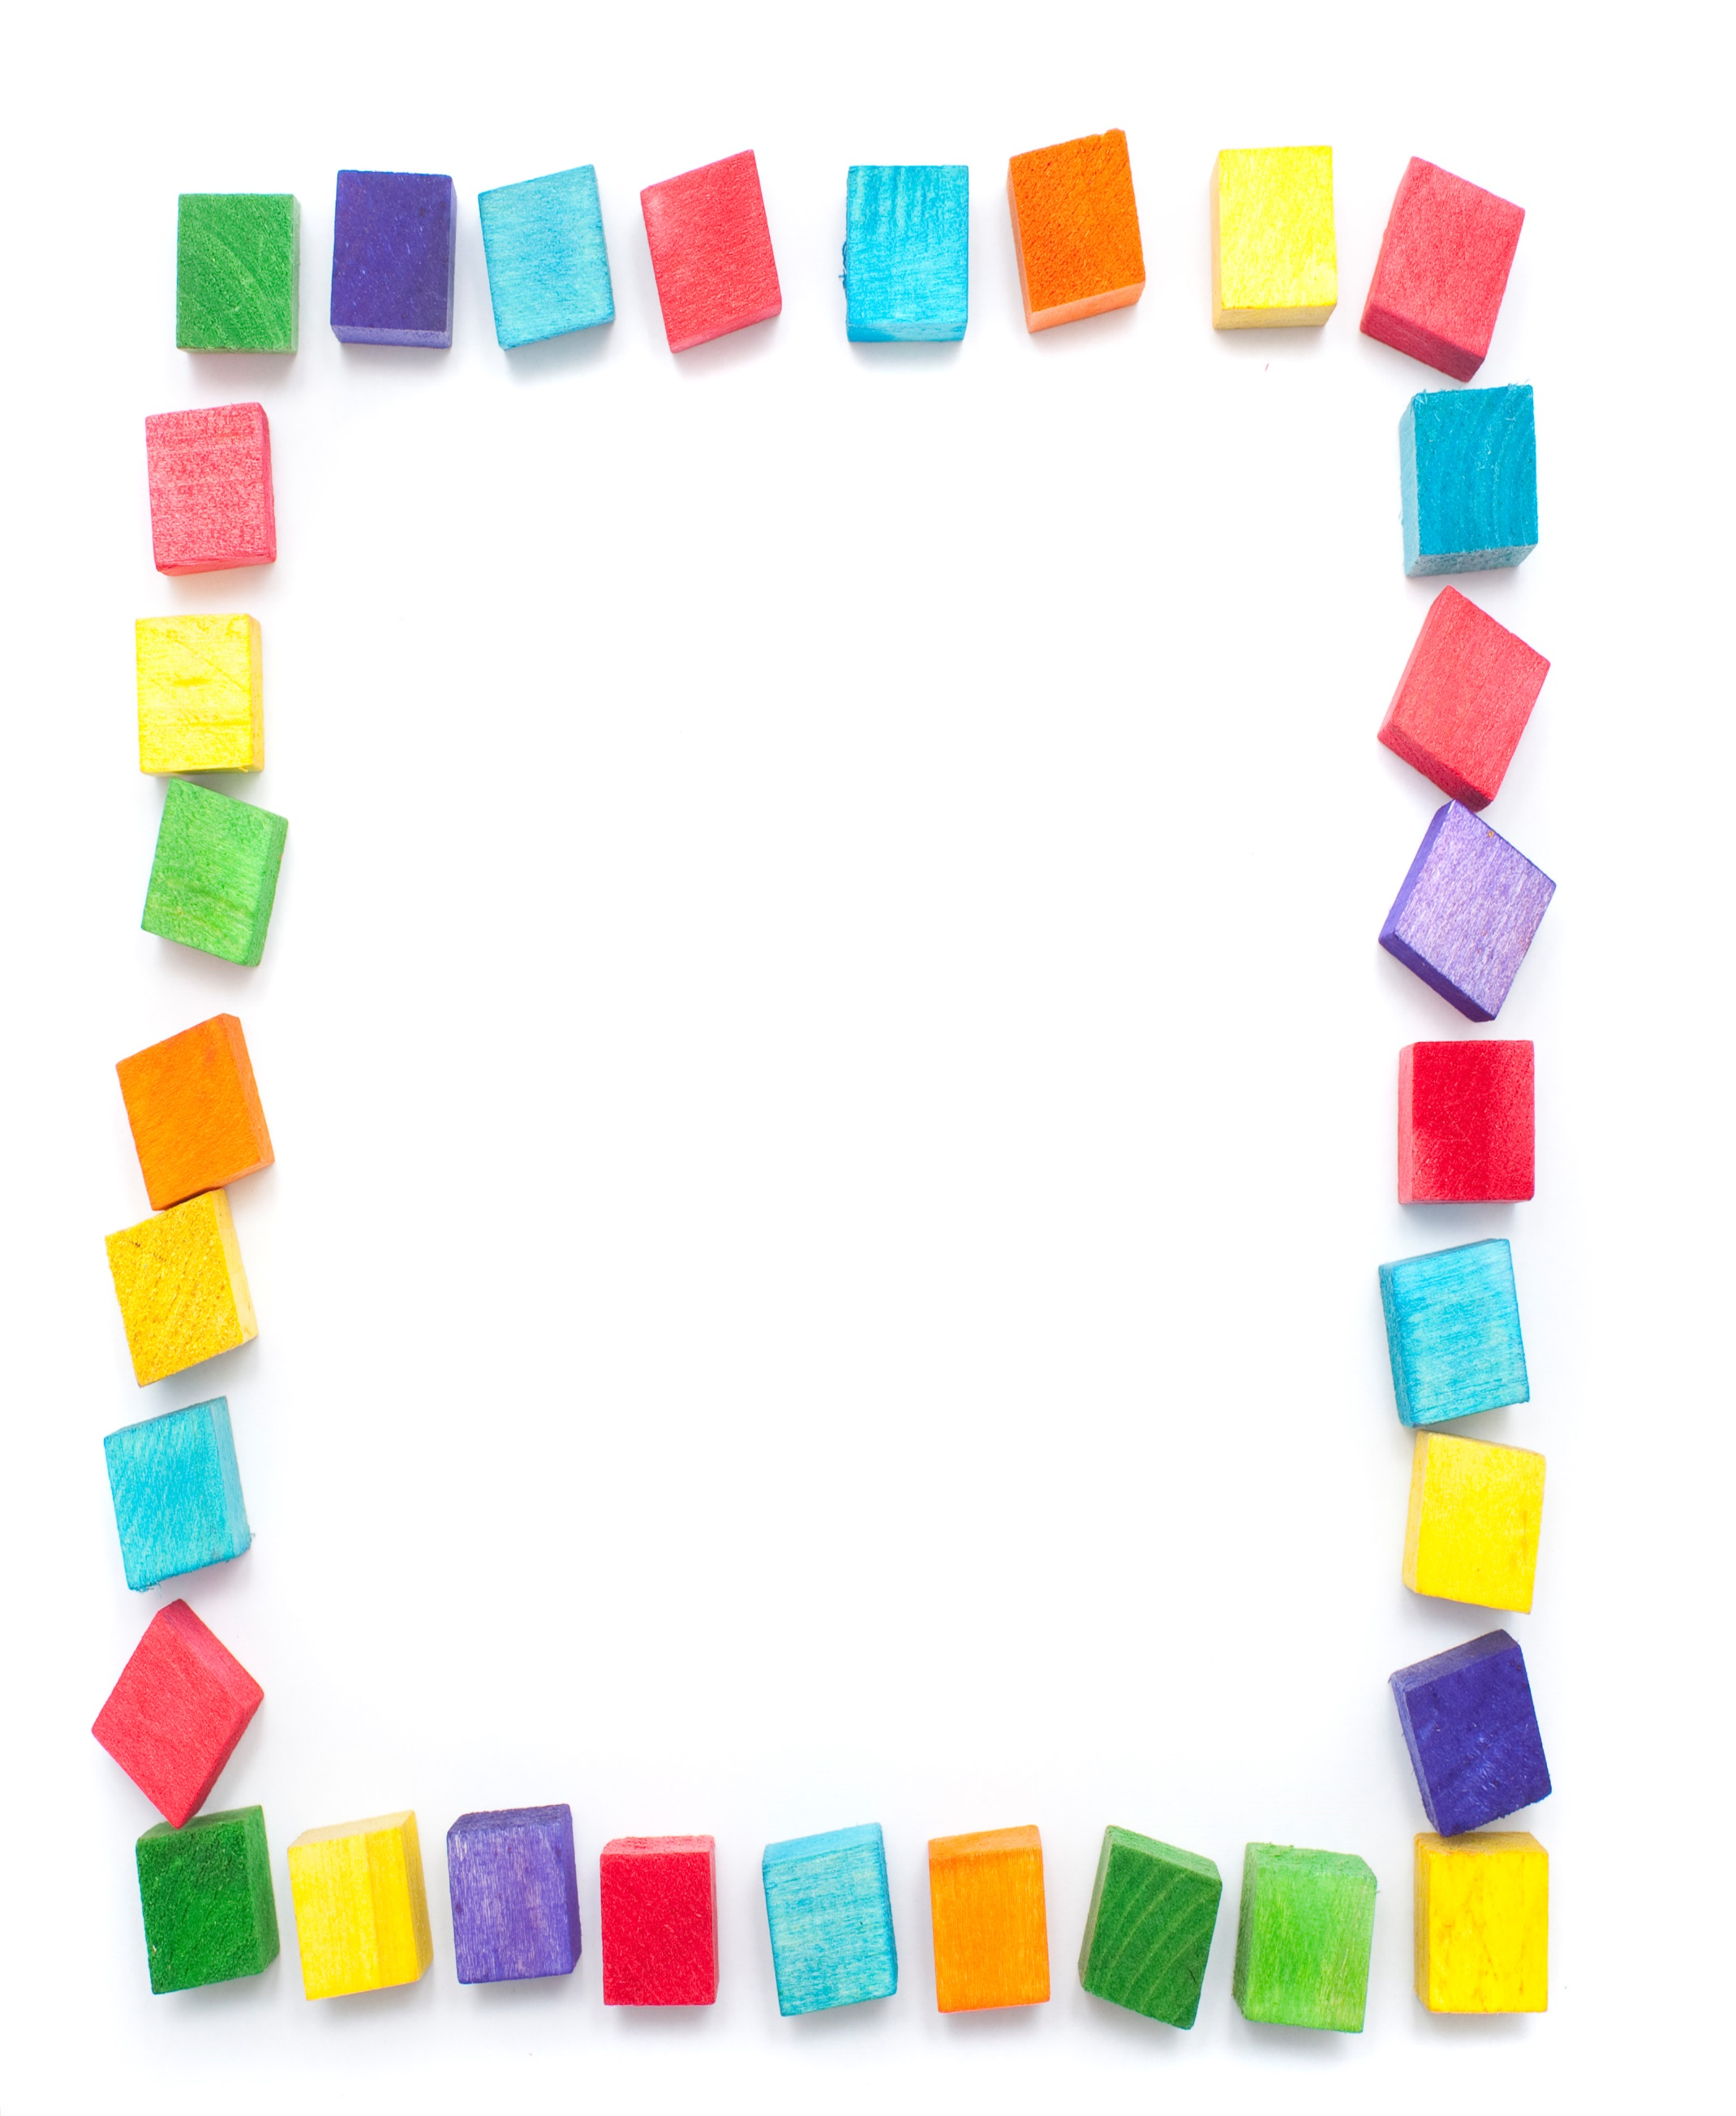
Terrific Three’s
Week of: June 15th - June 19th Lesson: I Have Favorite Toys
Bible Verse: “Be kind to one another” (Ephesians 4:32)
Letter: Cc Number: 3 Color: Yellow Shape: Triangle
Purpose: The purpose of this unit is to give children opportunities to use and talk about their favorite toys and help them become aware of the kinds of toys Jesus might have played with when he was a child.
June 15 - June 19th | Monday | Tuesday | Wednesday | Thursday | Friday
Art | Making toys | Painting with toys | Making wind toys | Pasting pictures of toys | Making paper bag puppets
Nature | Using bath toys | Lining up toys | Weighing toys | Observing windup toys | Favorite wooden toys
Books & Listening | Listening to books about toys | Looking at toy catalogs | Telling a story with a puppet | Enjoying a wordless picture book | Reading about toy bears
Blocks | Enjoying unit blocks | Playing toy store | Playing with vehicles | Using paper towel tubes | Building a house for a toy
Music | Making a hand instrument | Using a rhythm instrument | Pretending to be toys | Musical chairs | Head, Shoulders, Knees and toes
Puzzles & Manipulatives | Working wooden puzzles | Sorting toys | Playing a memory game | Using beads and laces | Sequencing
Home Living | Shopping for toys | Playing with homemade toys | Having a tea party | Washing toy dishes | Wrapping dolls with a blanket
Writing | Coloring the letter of the week | Coloring the number of the week | Tracing the letter of the week | Tracing the number of the week | Coloring the shape of the week
Kindness Curriculum:  Polite and Impolite | Learn about different behaviors | Being polite and impolite to our dolls | Saying Thank You and No Thank You | Discuss the definition of polite | Discuss what we have learned

