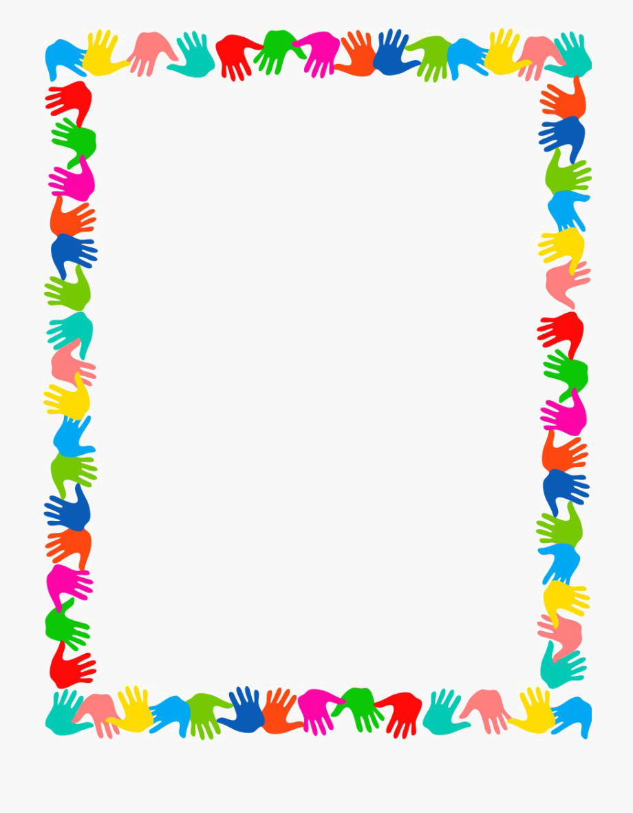
Terrific Three’s
Week of: June 8th - June 12th Lesson: I Make Friends at Preschool
Bible Verse: “We work together” (1 Corinthians 1:24)
Letter: Bb Number: 2 Color: Blue Shape: Square
Purpose: The purpose of this unit is to help preschoolers better understand the concept of having friends and to provide activities that will give them opportunities to develop friendships at school.
June 8th - June 12th | Monday | Tuesday | Wednesday | Thursday | Friday
Art | Painting at the easel | Making cards for friends | Drawing with the sides of crayons | Using scissors | Pasting pictures on a mural
Nature | Describing friends | Sorting blue objects | Using a bug keeper | Talking about pets | Sharing a plant
Books & Listening | Enjoying a picture album | Reading about friends | Telling stories with puppets | Looking at books with a friend | Relating concepts to experiences
Blocks | Building with unit blocks | Playing with traffic signs | Labeling structures | Using stand-up figures | Building with Legos
Music | Singing with friends | Tapping to music | Listening to music | Listening to friends’ voices | Playing instruments
Puzzles & Manipulatives | Sorting pictures | Playing a happy/sad face game | Working puzzles | Working with a lock board | Lacing
Home Living | Telephoning friends | Getting ready for school | Playing with baby dolls | Sharing a snack | Writing letters to friends
Writing | Coloring the letter of the week | Coloring the number of the week | Tracing the letter of the week | Tracing the number of the week | Coloring the shape of the week
Kindness Curriculum:  Feather Painting | What does gentle mean? | Talk about relaxation | Playing with feathers | “Painting” our friends | Feather painting pictures

