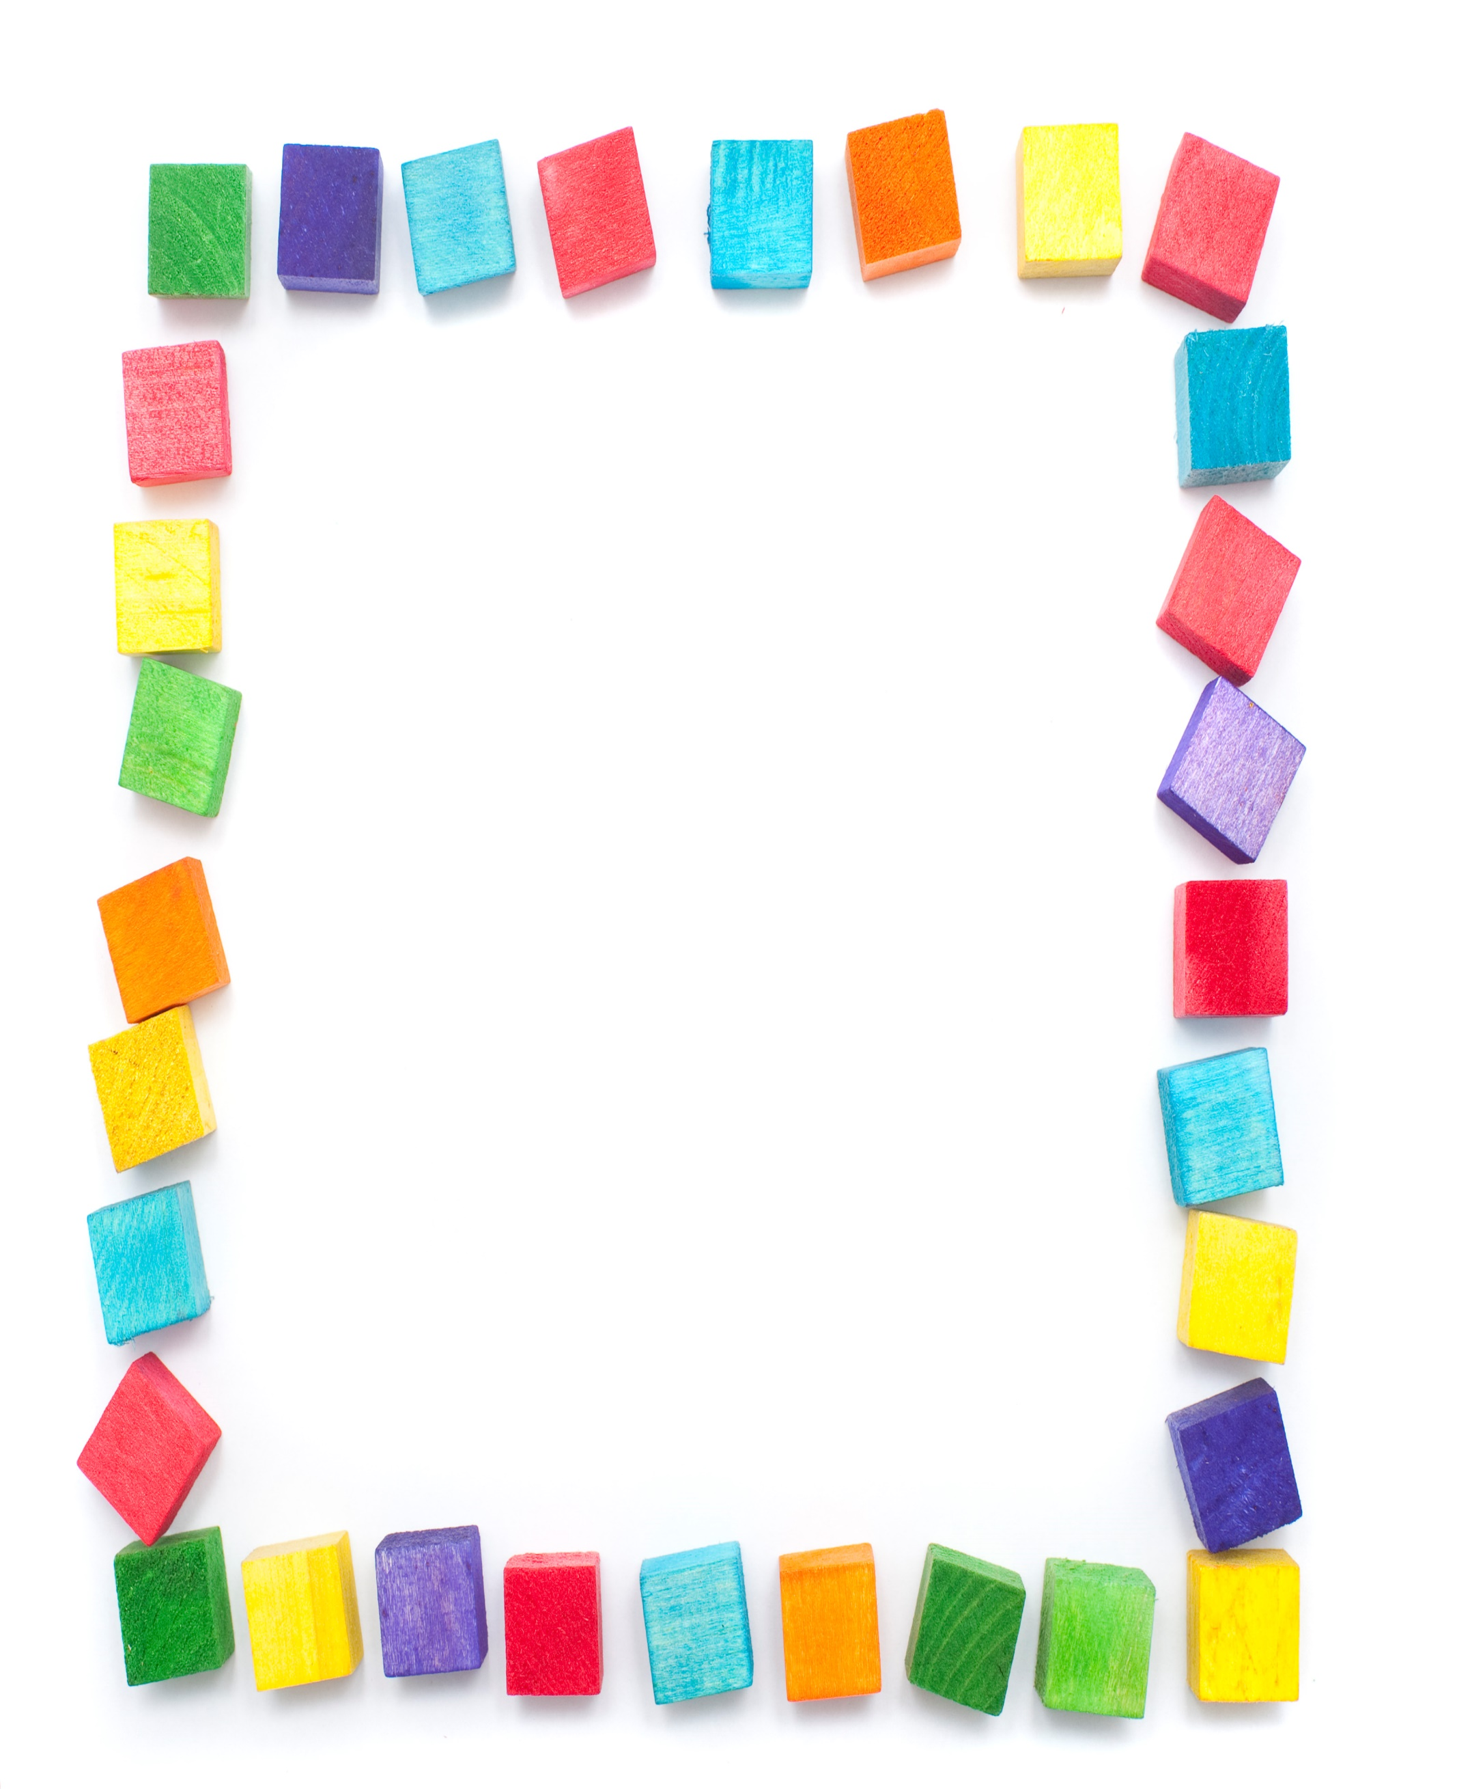
Blessed Two’s Lesson Plan
Week of: June 15th -19th, 2020
Lesson of the Week: I Learn Through Play
Bible story(s): Timothy Heard Stories About God (Acts 16:1-3)
Color: Orange Shape: Triangle Number: 6 Letter : Mm
 | MONDAY | TUESDAY | WENDESDAY | THURSDAY | FRIDAY
Art | Painting on Mirrors | Painting on Mirrors | Making Circle Prints | Making Circle Prints | Painting at the Easel
Nature and Science | Viewing with Color Scoops | Viewing with Color Scoops | Finding What Will Float and What Won't | Finding What Will Float and What Won't | Playing at the Water Table
Books & Listening | Reading About Babies | Reading About Babies | Listening to a Book on Tape | Listening to a Book on Tape | Reading with a Doll
Block Center | Pulling Blocks in a Box | Pulling Blocks in a Box | Stacking Blocks | Stacking Blocks | Playing with Wooden Blocks
Home living | Pretending to Be Chefs | Pretending to Be Chefs | Decorating Party Bags | Decorating Party Bags | Washing Baby Doll
Music | Parading in our Hats | Parading in our Hats | Following Music Instruction | Following Music Instruction | Playing with Colorful Scarves
Puzzles & Manipulatives | Filling and Dumping | Filling and Dumping | Moving Cotton Balls | Moving Cotton Balls | Matching with Nuts and Bolts
Kindness Curriculum | Discuss Friendship | Discuss Friendship | Friends are Kind | Friends are Kind | Review Friendships

