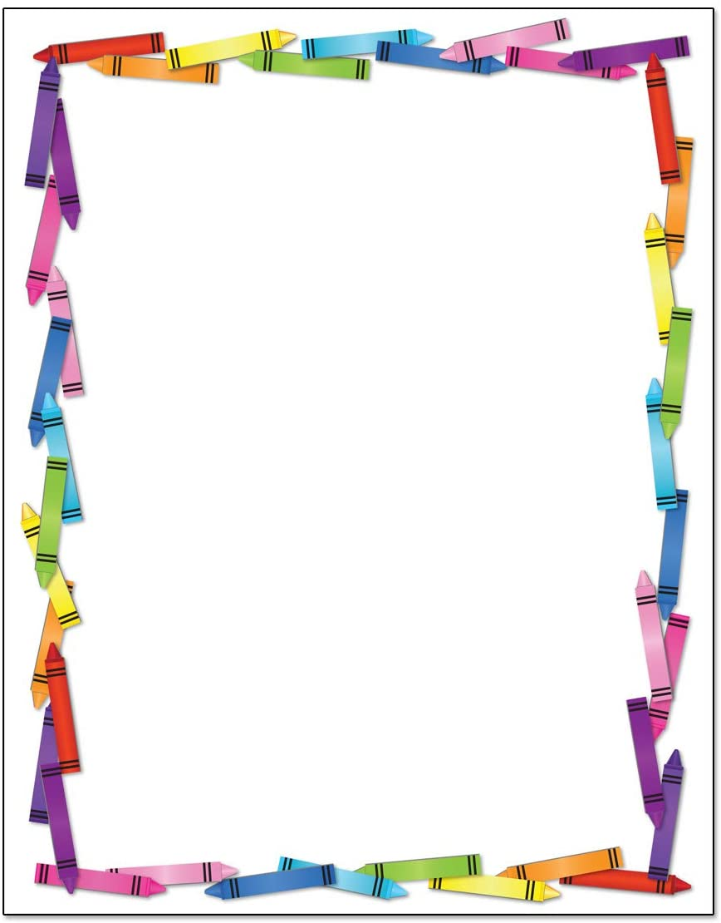
Blessed Two’s Lesson Plan
Week of: June 1st- June 5th, 2020
Lesson of the Week: I am Learning to Help
Bible story(s): Rachel Helped at Home (Genesis 29:1-9)
Bible Verses: (2 Corinthians 1:24) We are Helpers
(2 Timothy 1:3) I Thank God
Color: Orange Shape: Triangle Number: 2 Letter : Bb
 | MONDAY | TUESDAY | WENDESDAY | THURSDAY | FRIDAY
Art | Painting with Gadgets | Painting with Gadgets | Making ''My Family'' Picture | Making ''My Family'' Picture | Coloring with Crayons
Block Center | Playing with Wooden Family Figures | Playing with Wooden Family Figures | Building a Box House | Building a Box House | Playing with Textured Blocks
Books & Listening | Preparing the Center | Preparing the Center | Helping Take Care of Books | Helping Take Care of Books | Helping Twos Find Interest in Books
Home Living | Washing the Baby Doll | Washing the Baby Doll | Helping at My School | Helping at My School | Sorting Plastic Spoons and Forks
Music Center | Enjoying Music | Enjoying Music | Listening to Quite Music | Listening to Quite Music | Recording My Voice
Nature  Center | Helping Take Care of Our Play Yard | Helping Take Care of Our Play Yard | Playing with Friends | Playing with Friends | Observing Nature Items
Puzzles  &  Manipulatives | Working Puzzles | Working Puzzles | Matching Objects to Their Shapes | Matching Objects to Their Shapes | Telling a Story
Kindness Curriculum Friendship | Help from Friendships | Find a Shaking Partner | How do You do Song | Rotating Circle of Friends | Review Friendships

