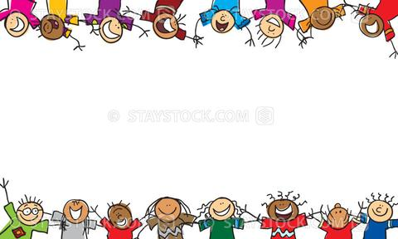
Blessed Two’s Lesson Plan
Week of: May 4th- May 8th, 2020
Lesson of the Week: We have Fun with Friends
Bible story(s): Jonathan's Special Friend (Samuel 14:49)
Color: Orange Shape: Octagon Number: 8 Letter : Gg
 | MONDAY | TUESDAY | WENDESDAY | THURSDAY | FRIDAY
Art | Painting with an Eyedropper | Painting with an Eyedropper | Creating Bookmarks | Creating Bookmarks | Free Art
Block Center | Having Fun with Large Cardboard Boxes | Having Fun with Large Cardboard Boxes | Playing with Friends | Playing with Friends | Going on a Safari
Books & Listening | Reading Books with Friends | Reading Books with Friends | Making Book Bags | Making Book Bags | Sharing a Friends Picture Album
Home Living | Playing with Water | Playing with Water | Sorting Silverware | Sorting Silverware | Making Pudding
Music Center | Listening to Cassette/ Cd | Listening to Cassette/ Cd | Singing Songs | Singing Songs | Playing Classical Music
Nature  Center | Learning about Fastest and Slowest | Learning about Fastest and Slowest | Watching a Snail's Home | Watching a Snail's Home | Going on a Safari
Puzzles  &  Manipulatives | Working Inlay Wood Puzzles | Working Inlay Wood Puzzles | Matching and Sorting | Matching and Sorting | Lacing Cards
Kindness Curriculum | Talk About Gentleness | Talk About Gentleness | Bathing Babies | Bathing Babies | Review Gentleness

