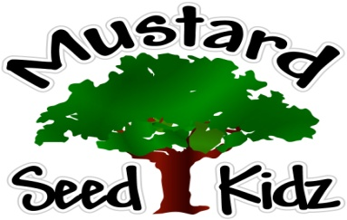

July 20th-24th
Breakfast | Monday | Tuesday |  | Wednesday | Thursday | Friday
 | Multi-Grain Kix Cereal  Applesauce  Milk | Waffles/  Pancakes  Fresh Strawberries  Milk |  | Multi-Grain Cheerios  Sliced Pears  Milk | Multi-Grain Blueberry Muffin  Fruit Cocktail  Milk | Multi-Grain Frosted Mini Wheat Cereal  Apple Slices  Milk
Lunch | Chicken Sandwich on a Bun  Green Peas  Sliced Peaches  Milk |  | Hamburger on a Bun  Baked Beans  Mandarin Oranges  Milk | Sweet & Sour Chicken w/ White Rice  Sliced Carrots Pineapple  Milk | Pizza Roll w/ Peperoni & Mozzerella  Fresh Carrots w/ Ranch  Pears  Milk | Baked Chicken Nuggets  Corn  Mixed  Tropical Fruit  Milk
Snack | Wheat Thins  Yogurt  String Cheese | Animal Cookies  Yogurt |  | Goldfish  Raisins | Multi-Grain Honey Graham Crackers  Milk | Pretzels  Cheese Sauce

