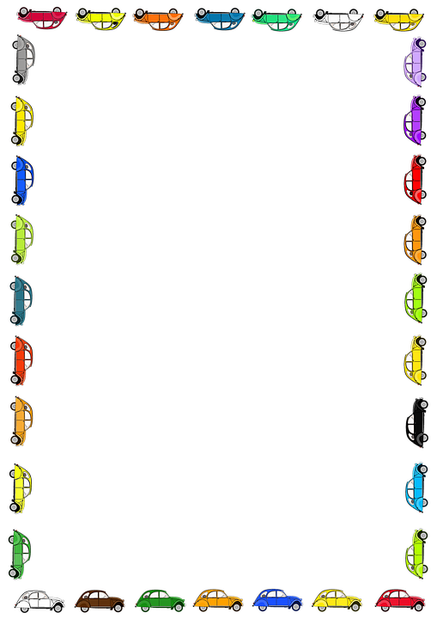
Blessed Two’s Lesson Plan
Week of: July 20th-24th
Lesson of the Week: I Travel with My Family
Bible Story: Jesus' First Trip Bible Verse: (Genesis 1:21) “God made the fish” & (Genesis 2:9) “God made the trees”
Color: Blue Shape: Circle Number: 5 Letter : Dd
 | MONDAY | TUESDAY | WENDESDAY | THURSDAY | FRIDAY
Art | Rubbing Crayons on Texture Boards | Rubbing Crayons on Texture Boards | Gluing Colored Sand | Gluing Colored Sand | Finger Painting
Block Center | Playing with Transportation Cars | Playing with Transportation Cars | Playing with Teacher Made Train | Playing with Teacher Made Train | Looking at Pictures about Taking a Trip
Books & Listening | Looking at Books about Getting Ready to Travel | Looking at Books about Getting Ready to Travel | Listening to Books about Trucks | Listening to Books about Trucks | Listening to a Teacher Made Book about Ways to Travel
Home Living | Playing in a Pretend Car | Playing in a Pretend Car | Playing with a Suitcase and Dress-Up Clothes | Playing with a Suitcase and Dress-Up Clothes | Playing with Doll and Diaper Bag
Music Center | Playing with Shakers | Playing with Shakers | Singing Action Songs About Transportation | Singing Action Songs About Transportation | Playing with a Car and a Cassette Tape
Nature  Center | Making an Aquarium | Making an Aquarium | Feeding Fish | Feeding Fish | Going on a Look and Listen Walk
Puzzles  &  Manipulatives | Matching Transportation Sounds | Matching Transportation Sounds | Playing with Snap Lock  Beads | Playing with Snap Lock Beads | Playing with Wooden Inlay Puzzles
Kindness Curriculum  Friendship | Promote Friendships, identify classmates | Collect our Materials | Play Firefly Game | Listen to "Sam and the Firefly" with Friends | Review Friendship

