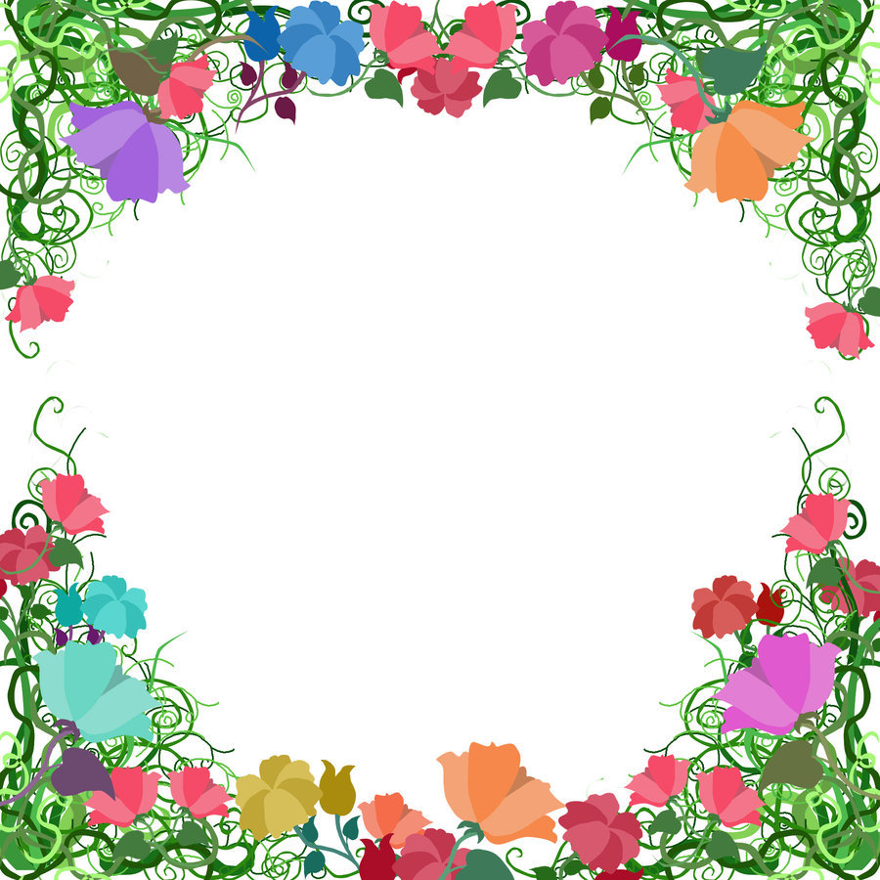
This Photo by Unknown Author is licensed under CC BY
Blessed Two’s Lesson Plan
Week of: July 6th-13th, 2020 Lesson of the Week: We Thank God for Plants
Bible Story(s): God Made the Flowers
(Genesis 1:11) “God made the flowers” & (Genesis 1:16) “God made the sun”
Color: White Shape: Diamond Number: 3 Letter: Ff
 | MONDAY | TUESDAY | WENDESDAY | THURSDAY | FRIDAY
Art | Printing with Sponges | Printing with Sponges | Painting with Tempera at an Easel | Playing with Play Dough | Happy 4th
Block Center | Playing with a Toy Wheelbarrow | Playing with a Toy Wheelbarrow | Playing with Branches and Gardening Gloves | Looking at Flower Seed Packets | Of July
Books & Listening | Looking at the Bible and Flowers | Looking at the Bible and Flowers | Looking at a Book about Trees | Looking at a Book About Rain | MSK will
Home Living | Wearing Sunglasses and Sunhats | Wearing Sunglasses and Sunhats | Washing Dishes | Dressing for Spring | Be Closed
Music Center | Singing with a Visitor | Singing with a Visitor | Playing with Teacher-Made Instruments | Looking at the Bible and Singing
Nature  Center | Planting Flowers | Planting Flowers | Looking at Books about Plants | Looking at Plants and the Bible | Have a Safe
Puzzles  &  Manipulatives | Playing with a Wall Puzzle | Playing with a Wall Puzzle | Playing with a Teacher-Made Puzzle of Boxes | Working Wooden Inlay Puzzles | And Blessed
Kindness Curriculum  Empathy | To have fun while encouraging and supporting others | Form a Bucket Brigade | Blow a Balloon | Review of Empathy | Holiday Weekend!

