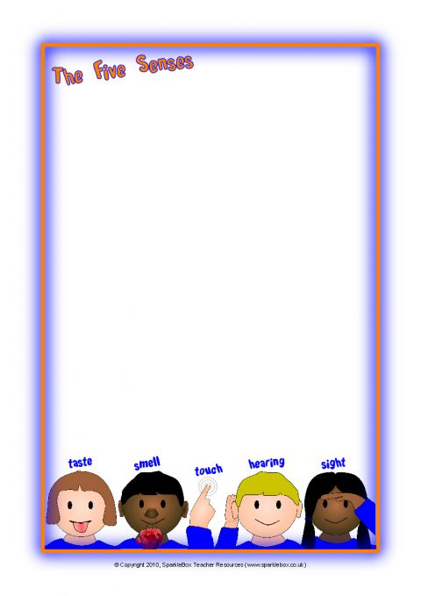
Terrific Threes & Fours
Week of: July 13th-17th Lesson: I Learn Through My Senses
Bible Verse: “God made us” (Psalms 73:1)
Letter: Gg Number: 7 Color: White Shape: Oval
Purpose: The purpose of this unit is to provide opportunities for children to use their senses and to develop an awareness that the ability to see, hear, smell, touch and taste are gifts from God.
 | Monday | Tuesday | Wednesday | Thursday | Friday
Art | Painting with ice | Drawing on sandpaper | Finger painting to music | Painting at the easel | Making a chart
Nature | Exploring seashells | Pouring water | Looking through color tubes | Muffling and ticking sounds | Taking a walk
Books & Listening | Learning about senses | Listening to predictable books | Hearing poetry | Matching sounds and pictures | Hearing car sounds
Blocks | Using bristle blocks | Discovering our senses | Stacking and listening | Building towers | Playing with toy vehicles
Music | Playing instruments | Playing the xylophone | Inventing noisemakers | Listening to animal sounds | Dancing with friends
Puzzles & Manipulatives | Using a feely tube | Working wooden puzzles | Sorting jar lids | Working storybook puzzles | Playing a listening game
Home Living | Measuring oats | Washing dishes | Listening to home sounds | Preparing fruit salad | Making muffins
Writing | Coloring the letter of the week | Coloring the number of the week | Tracing the letter of the week | Tracing the number of the week | Tracing/coloring the shape of the week
Kindness Curriculum  Kiss Pictures | What does love mean? | How do we show we love someone | Doing what we love | Making faces | Making Kiss Pictures

