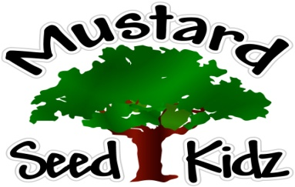

August 10th-14th
Breakfast | Monday | Tuesday |  | Wednesday | Thursday | Friday
 | Multi-Grain Chex Cereal  Fruit Cocktail  Milk | Multi-Grain Cheerios Cereal  Sliced Peaches  Milk |  | Multi-Grain English Muffin w/Jelly  Tropical Fruit  Milk | Multi-Grain Kix Cereal  Pears  Milk | Multi-Grain Biscuits  Pineapple  Milk
Lunch | Baked Ziti w/Meat Sauce  Sliced Carrots  Pineapple  Milk |  | Chicken Nuggets  Mixed Vegetables  Apple Slices  Milk | Corn Dog  Baked Beans  Sliced Peaches  Milk | Mexican Chicken Casarole  Sweet Corn  Diced Pears  Milk | Peperoni Pizza  Fresh Broccoli  Mandarin Oranges  Milk
Snack | Wheat Thins  Peperoni | Cheez-Itz  Applesauce |  | Pretzels  String Cheese | Chex Mix  Raisins | Animal Cookies  Yogurt

