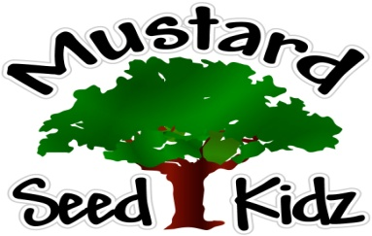

This Photo by Unknown Author is licensed under CC BY-SA-NC

Breakfast | Monday | Tuesday | Wednesday | Thursday | Friday
 | Multi-Grain Life Cereal  Sliced Pears  Milk | Multi-Grain Chocolate/ Blueberry Muffin  Sliced Peaches  Milk | Multi-Grain Cheerios Cereal  Pineapple Tidbits  Milk | Multi-Grain Pancakes/Waffles  Fruit Cocktail  Milk | Multi-Grain Biscuits  Sausage Gravy  Sliced Pears  Milk
Lunch | Breaded Chicken Nuggets  Green Beans  Fruit Cocktail  Milk | Beef Sloppy Joe Sandwich  Corn  Tropical Fruit  Milk | Sliced Turkey & Cheese on a  Wrap  French Fries  Apples  Milk | Chicken Casarole  White Rice & Broccoli  Sliced Oranges  Milk | Corn Dog on a Stick  Sliced Carrots Peaches  Milk
Snack | Pretzels  Hummus | Animal Cookies  Applesauce | Cheez-Itz  Tropical Fruit | Graham Crackers  Milk | Chocolate Trail Mix
August 24th-28th

***Children under the age of two are served Whole milk***
***Children two years and older are served Fat Free or 1% milk***

