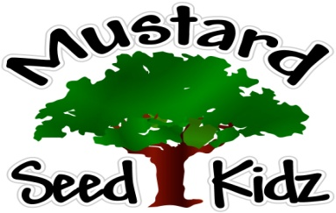

Breakfast | Monday | Tuesday | Wednesday | Thursday | Friday
 | Multi-Grain Corn Flake Cereal  Sliced Bananas  Milk | French Toast Sticks  Apple Slices  Milk | Multi-Grain Cheerios  Mandarin Oranges  Milk | Whole-Grain Life Flake Cereal  Sliced Pears  Milk | Multi-Grain Pancake & Sausage on a Stick  Applesauce  Milk
Lunch | Breaded Fish Sticks  French Fries  Sliced Pears  Milk | Italian Chicken Steamed Broccoli  Fruit Cocktail  Milk | Macaroni w/ Cheese  Diced Ham  Sliced Carrots  Diced Peaches  Milk | Ground Turkey Tacos on a Wrap w/Sour Cream  Corn  Tropical Fruit  Milk | Breaded Chicken Fingers  Mashed Potatoes  Pineapple Tidbits  Milk
Snack | Bagel Chips  Cream Cheese | Graham Crackers  Applejuice | Chocolate Muffin  Milk | Pretzels  Wow Soy Butter | Cheez-Itz  Raisins
September 14th-18th

***Children under the age of two are served whole milk***
***Children two years and older are served Fat Free or 1% milk***

