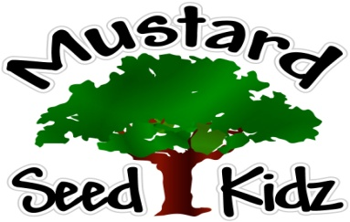

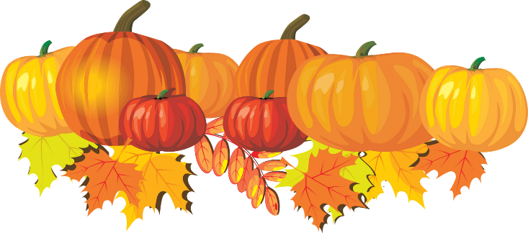

Breakfast | Monday | Tuesday | Wednesday | Thursday | Friday
 | Multi-Grain Cheerios Cereal  Diced Pears  Milk | Multi-Grain Corn Flake Cereal  Sliced Peaches  Milk | Multi-Grain French Toast Sticks  Pineapple Tidbits  Milk | Multi-Grain Raisin Bran Cereal  Mandarin Oranges  Milk | Multi-Grain Chocolate Chip Breakfast Cake  Sliced Apples  Milk
Lunch | Breaded Chicken Nuggets  Corn  Fruit Cocktail  Milk | Macaroni & Cheese w/  Diced Ham  Sliced Carrots  Applesauce  Milk | Meat ball Sub on a Roll  Green Beans  Tropical Fruit  Milk | Teriyaki Chicken  Stir Fry Vegetables  Pineapples  Milk | Beef  Cheeseburger  on a Bun  Tator Tots  Diced Pears  Milk
Snack | Pretzels  Cheese Sauce | Chex Mix  Raisins | Tortilla Chips  Salsa | Graham Crackers  Apple Juice | Animal Cookies  Milk
October 12th-16th

***Children under the age of two are served whole milk***
***Children two years and older are served Fat Free or 1% milk***

