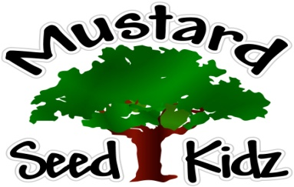

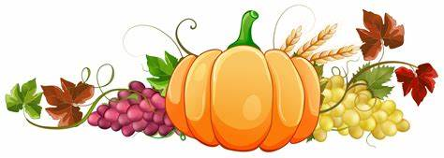

Breakfast | Monday | Tuesday | Wednesday | Thursday | Friday
 | Multi-Grain Blueberry Muffin  Mandarin Oranges  Milk | Multi-Grain Frosted Mini Wheats  Sliced Banana  Milk | Non-Fat  Greek Yogurt  Mixed Berries  Milk | Multi-Grain Corn Flake Cereal  Pineapple Tidbits  Milk | Multi-Grain Waffles  Apple Slices  Milk
Lunch | Breaded Fish Sticks  Mixed Vegetables  Diced Pears  Milk | BBQ Kielbasa  Green Beans  Pineapple Tidbits  Milk | Multi-Grain Breaded Chicken Nuggets  Carrots  Applesauce  Milk | Mashed Potatoes  Ground Beef  Corn  Oranges  Milk | Chicken Salad Wrap  Pickle Slices  Fruit Cocktail  Milk
Snack | Wheat Thins  Hummus | Bagel Chips  Cream Cheese | Animal Cookies  Milk | Chex Mix  Apple juice | Pretzels  Cheese Sauce
October 19th-23rd

***Children under the age of two are served whole milk***
***Children two years and older are served Fat Free or 1% milk***

