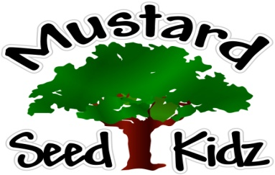

Breakfast | Monday | Tuesday | Wednesday | Thursday | Friday
 | Multi-Grain Corn Flakes  Mandarin  Oranges  Milk | Multi-Grain Pancakes/  Waffles  Sliced Peaches  Milk | Multi-Grain Cheerios Cereal  Diced Pears  Milk | Multi-Grain Blueberry Muffins  Diced Apples  Milk | Multi-Grain Rice Crispie Cereal  Pineapple Tidbits  Milk
Lunch | Hot Dot on a Bun  Green Peas  Diced Pears  Milk | Pulled BBQ  Chicken on a Bun  Baked Beans  Fruit Cocktail  Milk | Ground Beef over Nachos  Corn  Apple Slices  Milk | Sweet & Sour Chicken  Stir Fry Mixed Vegetables  Sliced Peaches  Milk | Breaded Chicken Nuggets  Tator Tots  Sliced Apples  Milk
Snack | Carrots  Ranch  Applesauce | Chocolate Muffin  Milk | Mixed Vegetables  Yogurt | Tortilla Chips  Cheese Sauce | Non-Fat Greek Yogurt  Pretzels
October 26th-30th

***Children under the age of two are served whole milk***
***Children two years and older are served Fat Free or 1% milk***

