August 2021
Monday Tuesday Wednesday Thursday Friday
2  Leave @ 10:30 | 3  Carnival Day  MSK @ 1:30 | 4  Leave @ TBA | 5  Stem Day  Stay @ MSK | 6  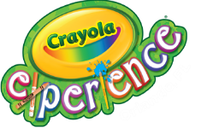  Leave @ 8:45
9  Summer Bash  Stay @ MSK | 10  First Day of School | 11 | 12 | 13
16 | 17 | 18 | 19 | 20

DUE TO COVID-19 TRIPS AND PRICING CAN CHANGE!

