July 2021

Monday Tuesday Wednesday Thursday Friday
 |  |  | 1  Gleason Park & Picnic  Leave @ 10:00 | 2  Painting with a twist  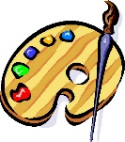  Stay @ MSK
5  MSK CLOSED | 6  Leave @ TBA | 7  Magic Show  MSK @ 1:00 | 8  Medieval Times  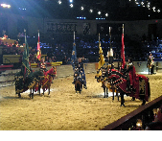  Leave @ 8:45 | 9 Knecht Park  Leave @ 10:00
12  Field of Dreams & Splash Pad  Leave @ 10:00 | 13  Cooking Day  Stay @ MSK | 14  Leave @ TBA | 15  Bowling  Leave @ 12:15 | 16  Galaxy Skate Way  Leave @ 10:15
19  Planet 3  Leave @ 9:45 | 20  Fee Ave Pool  Leave @ 8:30 | 21  Leave @ TBA | 22  Mini Golf w/ Big Idea Entertainment  MSK @ 1:30 | 23  Bike Day  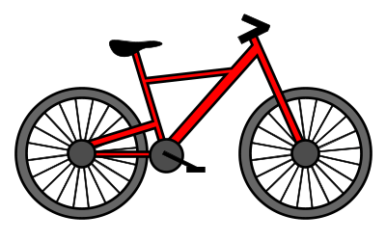  Stay @ MSK
26  Bubble Show w/ Big Idea Entertainment  MSK @ 10:00 | 27  Rhodes Park & Grill  Leave @ 10:00 | 28  Leave @ TBA | 29  Dinosaur Store Museum  Leave @ 9:00 | 30  Fee Ave Pool  Leave @ 8:30

DUE TO COVID-19 TRIPS AND PRICING CAN CHANGE!

