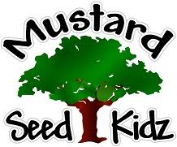
August 2022
Monday Tuesday Wednesday Thursday Friday
1  Magic Show Big Idea Entertainment | 2  MSK Talent Show | 3  Leave @ TBA | 4  Sebastian Park & Splash Pad  Leave @ 9:30 | 5  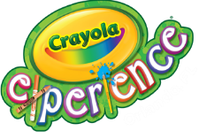  Leave @ 8:45
8  This Photo by Unknown Author is licensed under CC BY-NC  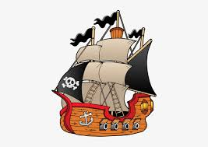  Pirate Dinner Show  Leave @ 10:00 | 9  Summer Bash  Stay @ MSK | 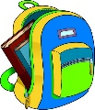10  First Day of School

