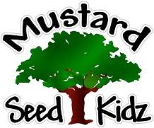
July 2022
Monday Tuesday Wednesday Thursday Friday
1
Water Day @MSK
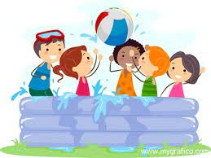
4  MSK CLOSED  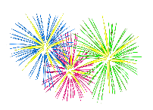 | 5  Painting W/O a Twist & Rhodes Park  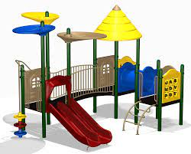  Leave @ 10:00 | 6  Leave @ TBA | 7  Urban Air  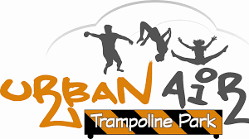  Leave @ 10:00 | 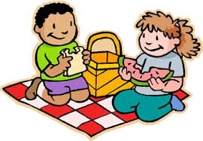  8 Picnic at  Gleason Park  Leave @ 10:30
11 Makotos  Leave @ 10:30 | 12  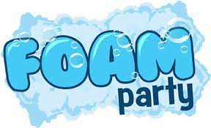  Fred Lee Park & BIG Idea Entertainment Foam Party  Park @ 10:30 | 13  Leave @ TBA | 14  Cocoa Riverfront Splash Pad  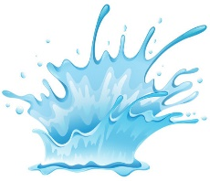  Leave @ 10:00 | 15  Chuck E Cheese  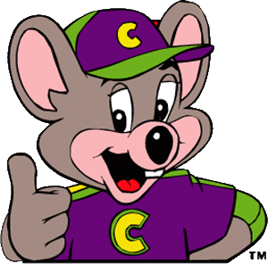  This Photo by Unknown Author is licensed under CC BY-NC-ND  Leave @ 10:15
18  Board Games and Ice Cream Sundaes | 19  Lets Plant It  Leave @ 9:30 | 20  Leave @ TBA | 21  Kickball at Knecht Park  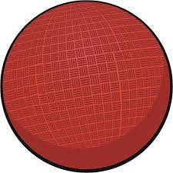  Leave @ 10:30 | 22  Bowling at Bowlero  Leave @ 10:00
25  Golf N Gator  & Gem Mining  Leave @ 9:00 | 26  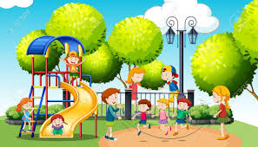  Fee Avenue Park  Leave @ 10:30 | 27  Leave @ TBA | 28  Romelia Farm  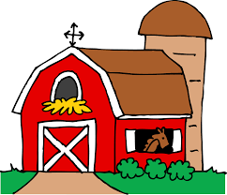  (Obloy)  Leave @ 9:00 | 29  Field of Dreams Splash Pad  Leave @ 10:30

