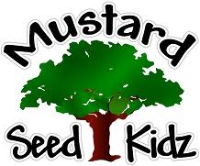
JUNE 2022
Monday Tuesday Wednesday Thursday Friday
 |  | 1 | 2  Dino Store  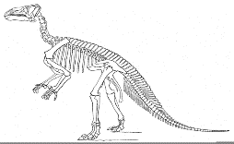  Adventure  Leave @ 9:00 | 3  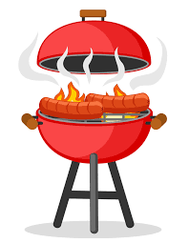  Rhodes Park  Leave @ 10:00
6  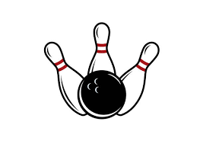  Shore Lanes Bowling  Leave @ 11:00 | 7  Field of Dreams  Splash Pad  Leave @ 10:00 | 8  Leave @ TBA | 9  Science Day  This Photo by Unknown Author is licensed under CC BY-NC-ND | 10  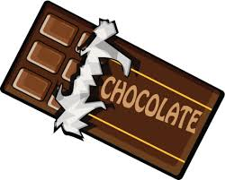  Chocolate  Kingdom  Leave @ 9:45
13  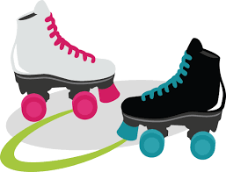  Galaxy Skateway  Leave @ 11 | 14 Fishing at Malabar Park  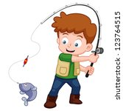  Bring Fishing Poles | 15  Leave @ TBA | 16  Rhodes Park  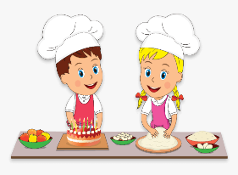  Leave @ 10:00  Big Idea Entertainment Bubble Show | 17  Cooking & a Movie @ MSK
20  Basketball at Ryckman Park  Leave @ 10:30 | 21  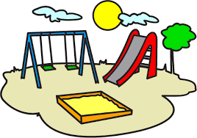  Turkey Creek and Lunch @ Knecht Park  Leave @ 10:00 | 22  Leave @ TBA | 23  Fired Up Pottery  Park  Ice Cream Party  Group 1  Leave @ 9:30 | 24  Fired Up Pottery  Park  Ice Cream Party  Group 2  Leave @ 9:30
27  Fred Lee Park  Relay Races  Leave @ 12:00 | 28  Wonder Works  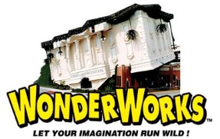  Leave @ 9:00 | 29  Leave @ TBA | 30

